WEEK – 1 2 3
- Artificial Intelligence (AI) is promising cutting-edge technology providing intelligent solutions in all sectors today. Define AI and describe applications of AI in different domain.
- Groups of developers want to work Collaboratively on big software project. Each developer in team is assigned one module. How git and GitHub help these developers to build project effectively?
- Summarize the challenges associated with Machine Learning
- How AI Software Development life cycle differs from traditional software development? Explain
- Summarize any two cloud deployment models
- Write steps to Create repository in GitHub and add file.
- Is data which is collected by various applications ethical in nature? Justify your answer
- How Big data is different from the data stored in traditional databases? Elaborate
- Differentiate between supervised machine learning and Unsupervised machine learning
- Explain different machine learning types
- Discuss various attributes of a high-quality data
- Here given the bating statistics of Indian great cricketer Anil Kumble. Perform the following operations- i) Aggregation ii) Grouping iii) Time series iv) Filter v) Vectorized
- Create a dataframe with following data
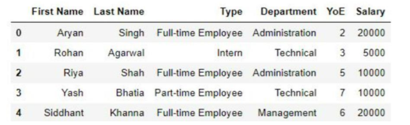
a. Make a pivot table which shows average salary of each type of employee for each department.
b. Make a pivot table which shows the sum and mean of the salaries of each type of employee and the number of employees of each type.
c. Make a pivot table which shows standard deviation for salary column.
14. create two series as shown using pd.series() function.
Series_A = [10,20,30,40,50] Series_B = [40,50,60,70,80].
- Get the items not common to both
- ii. Identify the smallest and largest element in the series A
- Find the sum of series B iv. Calculate average in the series A
- Find median in the given series B
15. Perform the following operations on Car manufacturing company dataset auto-mpg.csv given below using pandas
a. Read data from an existing file
b. Statistical details of dataset
c. Get all cars with 8 cylinders
d. Get the number of cars manufactured in each year.
16. Lee decides to walk 10000 steps every day to combat the effect that lockdown has had on his body’s agility, mobility, flexibility and strength. Consider the following data from fitness tracker over a period of 10days

Day number Steps walked
1 6012
2 4079
3 6386
4 5230
5 4598
6 5564
7 6971
8 7763
9 8032
10 8569

17. Write python code to explain map (), filter (), reduce (), lambda()

18. Assume Iris dataset and write the code
a. print first 5 record
b. print the size of the data for given data set
c. Use scatter plot to compare petal length and petal width
d. check for missing values
e. print summarizes of the dataset
f. Count plot for the spices
g. Visualize the distribution of any one column
h. Visualize the relationship between any two variable
i. Print the information of all column in the dataset
j. Visualize the spices column using bar graph

WEEK- 4 & 5

- The statistical summary of titanic dataset with respect to age and fare is as follows. Analysis and explain statistical matrices from summary.
- Difference between Covariance and Correlation.
- Describe the univariate and multivariate analysis
- Justify the Significance of Exploratory Data Analysis
- A data set is given to you creating a machine learning model. What are the steps followed before using the data for training the model? Elaborate each step.
- Explore different types of data in machine learning.
- For the given data set Perform the following operations: i) Check statistical info of the data set ii) Plot a line plot showing total profit on y axis and number column on x axis iii) Find the missing values iv) Find the sum of total profit v) Find the max value from Drawing sheets column
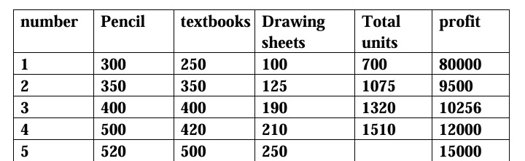

- How to handle the missing values in the dataset? Explain
- Explain different challenges involved in Data Integration.
- How to handle the outliers in the dataset? Explain
- Write python code to imputation the missing values in the dataset using, mean and median method
- A company wants to study iris dataset to make predictions. However, the data gathered is not clean for analysis. The company requests you to write a python code to perform the following operations for data driven competitive advantage (Assume dataset with missing values)
- A company has collected customer comments on its products, rating them as safe or unsafe, using decision trees. The training dataset has the following features: id, date, full review, full review summary, and a binary safe/unsafe tag. During training, any data sample with missing features was dropped. In a few instances, the test set was found to be missing the full review text field. For this use case, which is the most effective course of action to address test data samples with missing features. Justify
- A dataset is given to you for creating machine learning model. What are the steps followed before using the data for training the model? Elaborate each step.
- Create two series as shown using pd.series() function.
Series A = [20, 30, 40, 50, 60]
Series B = [50, 60, 70, 80, 90]
- Get the items not common to both.
- Identify the smallest and largest element in the Series A.
- Find the sum of Series B.
- iv. Calculate mean in the Series A. 10M 10M 10M 10M
- v. Find median in the given Series B.
- Referring to the number of variables or features in a dataset and the focus of analysis. Explain univariate & multivariate data types with examples.
- Explore Data transformation with Normalization, Standardization, binary coding ,ranking transformation and discretization
- List and explain how to deal with missing values with different approaches?
- A Teacher assumes that 60% of his college students come from lower middle-class families justify the answer for this statement.
- Demonstrate Univariate, Multivariate and Bivariate analysis with suitable example?
- Classify Data discretization with suitable Python Construct?
- A company wants to study the agriculture production statistics dataset to make predictions. However, data gathered is not cleaned for analysis, a company request you to develop a code to quality data set
- Perform the Exploratory analysis for the given dataset and plot suitable graph
i)identify the Outliers
ii)perform data transformation

WEEK- 6 & 7
- Explain the evaluation matrix for classification as follows. 1) confusion matrix 2) Accuracy 3) F1 – score 4) AUC_ROC 5) Precision and Recall
- Build a data set and predict the heart disease based on BP, Sugar, Age, Gender and Cholesterol by using relevant operations
- The confusion matrix for a model is as shown below. Evaluate accuracy, precision, recall, Specificity and F1- Score, AUC-ROC
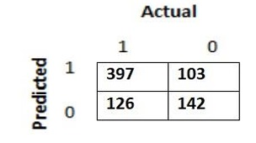

4. Given a dataset perform comparative analysis using decision tree and SVM algorithm and check accuracy.
5. Explain any 2 techniques of cross validation used in machine learning.
6. Compare Classification algorithms with Clustering algorithm.
7. A machine learning model was built to classify spam emails as spam(1) or not Spam(0) . the confusion matrix for the model is as shown below. Evaluate accuracy, precision, recall, specificity and F1-score.

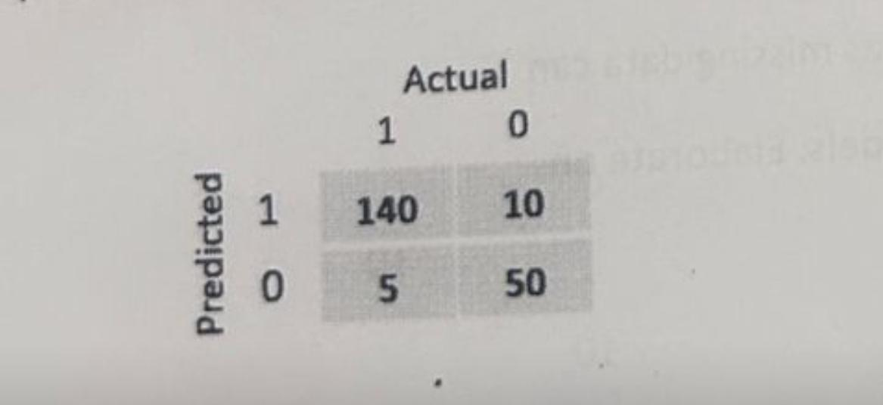

8. Explain different techniques of Cross Validation?
9. How to stop Overfitting in Decision Tree Classifier Explain it?
10. Explain Evaluation Metrics in Model Evaluation and Testing.
11. Perform data exploration, preprocessing and splitting on datasets Boston Housing price from Scikit learn
12. Perform data exploration, preprocessing and splitting on datasets Crop yield-past data.
13. Create a model to analyze the relation between CIE and SEE result. Build Linear regression Model using Stats model, Scikit Learn
14. Create a model to analyze the relation between Crop Yield vs Rain Fall rate
Build Linear regression Model using Stats model, Scikit Learn

WEEK- 8 & 9
- Define clustering and compare various clustering techniques.
- Describe the advanced ensemble techniques
- How to Choose the Right Number of Clusters in k-means clustering? Explain any one method
- Cluster the following eight points (with (x, y) representing locations) into three clusters: A1(2, 10), A2(2, 5), A3(8, 4), A4(5, 8), A5(7, 5), A6(6, 4), A7(1, 2), A8(4, 9) Initial cluster centres are: A1(2, 10), A4(5, 8) and A7(1, 2).
- Compare classification algorithms with clustering algorithm
- K-means clustering with Euclidean distance suffer from the curse of dimensionality. Is the statement true and why?
- The sinking of the Titanic is one of the most infamous shipwrecks in history. You are asked to build a machine learning model to predict whether a passenger survived or not. Describe each step you will follow to build this model. Description of dataset titanic.csv is as below
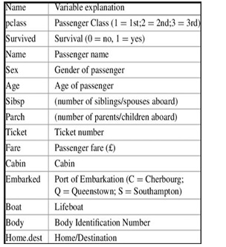

- Compare Bagging and Boosting.
- Discuss importance of dimensionality reduction in machine learning
- Explain dimensionality reduction using PCA
- Explain the working of SVM with its applications.
- Explain the different Ensemble Techniques.
- Explain K-means clustering.
- Explore ML Pipeline and versioning.
- Build Logistic regression model in python
- Build a SVM Model in python for Fish dataset from Kaggle.
- Build Random Forest-based model in python for Breast Cancer Wisconsin (diagnostic) dataset from sci-kit learn Or dataset from Kaggle .
- Build Dimensionality Reduction [PCA] using iris Dataset

WEEK- 10 & 11

- Discuss activation functions in Neural Network
- Explain neural network architecture.
- Differentiate between forward propagation and Back propagation
- For the given sentence “Machine Learning is best platform. To group over selves”. Visualize the data for the better understanding and perform the following operations
i )Word tokenization
ii) Sentence tokenization
iii) Dropping Stop word
iv) Stemming
v) Lemmatization
5. List and explain tools used to deploy the AI model using google cloud platform
6. Demonstrate stemming and Lemmatization concepts with suitable examples
7. Explain Tensorflow and keras.
8. Explain Cost function with How to measure loss and How to reduce Loss?
9. Why do we have to flatten the input data?
10. Get data, and explore Eg. Stroke Prediction Dataset | Kaggle or dataset from any other source
Prepare data: Dealing with - missing values - Categorical values, Labeled encoding - One hot coding
11. Prepare data : Feature scaling with StandardScalar() or other method Dropping unnecessary features Data splitting Dealing with imbalanced dataset
12. Why do we have to flatten the input data?
13. Building Shallow Neural Network with Keras Dense Layer
14. Building Deep Neural Network with Keras Dense Layers
15. Create a complete end to end neural network model using Keras Sequential Model and Keras Layer API Eg. MNIST dataset (classify handwritten numerals) or fashion-MNIST dataset or dataset from other source
16. Building deep learning model with TensorFlow and Keras
17. What are the steps of Text preprocessing /Normalization? Explain in Brief
18. Compare One hot Encoding with Bag of words with suitable example
19. N-grams are defined as the combinationsof N Keywords together consider the given “The greatest glory in Living lies not in never falling but in raising every Lies”
Generate bi grams for the above
Generate Tri grams for the above
20 Through a step-by-step process calculate TF/IDF for the given corpus and mention the words having highest value
Doc1: we are going to Mysore
Doc2: Mysore is a famous place
Doc3: we are going to famous place

